Metropolitan Emergency Managers Association
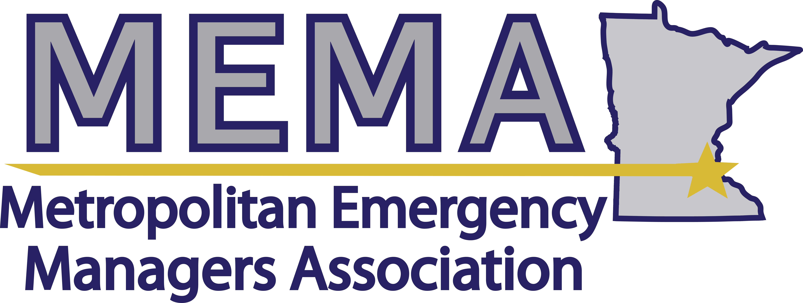
www.mema-mn.com | mema.mn.us@gmail.com

MEETING: GENERAL MEMBERSHIP
Date: September 4, 2019 | Time: 10:00am-12:00pm |  | Location: Bloomington Fire Station #1
Chairperson: Angela Eastman, President | Secretary: Toni Hauser
Attendees:

MEETING NOTES
Topic | Discussion and Agreements
Approval of the meeting notes | Motion/Second to approve the notes from April:
Board report | President  - MEMA is a membership-driven organization  - Please pay your dues  - Interest in receiving an Outlook invite?  - Comment card – fill out with ideas or feedback  - Thank you note from Gary Peterson’s family  Secretary  - Website updates: meeting schedule, store options  Treasurer  - Bank balance: $4,484.07
Liaison reports | AMEM  - Conference in September  - Lucy Angelis and Terry Stoltzman are AMEM reps  - Annual meeting will be Monday morning of the conference  Capitol  - Holding a suspicious indicator training, there are some spots open, need volunteers as role players  - November 5-7  GIS  - Regional monthly GIS meetings  - NextGen 911 data standards  - Met Council is doing aerial photography next spring  HSEM  - Staff changes: Bureau Directors are Joe Neuberger and Brian Olson; program and policy analyst is on second interviews; three current open positions  LE  - Wrapping up a busy summer  - Developing more robust shelter planning  Airport  - Construction is impacting one checkpoint, leading to the extensive lines  - 40-45k are going through each day  - Working with Ramsey County to finish invoicing for flood recovery  - WEA generator – can issue wireless alerts  - September 28 hiring fair – need 911, fire, police  - In the process of implementing an active threat plan, including training all airport employees  Coalition  - Next meeting is September 10  - Anthrax workshop September 5  - MNTrac training  - October 30 hospital evacuation simulation  - 2020 dispensing exercise  - Ebola training for all frontline hospitals  Military  - Leadership changes in both airwings  MNVOAD  - MNVOAD Tailgate event was held June 20 to showcase trailer and equipment resources  - Members responded to July flooding in Dodge County and July flooding in Renville County  - Additional deployments to Wisconsin for tornado response and Missouri for flooding  - Participated in the SEOC Radiological Emergency Preparedness drill on August 6  - Next meeting is September 26 at the Salvation Army offices in Roseville  NWS  - Radar is going to undergo upgrades starting next month  - Todd will provide a link for a map that includes the FAA radar  Xcel Energy  - Mutual aid movement for Hurricane Dorian response  - Implementing Veoci  Public Health  - Hep A outbreak in MN, 26 in the state, 9 in the metro, 3 in Hennepin – Hennepin County implemented ICS  - Patient tracking/reunification workshop held last week  Public works  - Mutual aid agreements for public works resources
EM Director Updates | Anoka  - Converted an unused county building for asset storage and AHIMT mobilization  Minneapolis  - Two new staff – Tracey Warsett, Becca Vierden  Saint Paul  - Booth at the State Fair, talked about access and functional needs planning  - Created mass casualty bags  Dakota  - Country music festival September 14  - Full scale exercise September 15  Hennepin  - Uneventful summer  - EOC rebuild for the Sheriff’s Water Patrol in 2020  - Next Mesonet installation will be in Long Lake  - 30 county departments are completing emergency plans  - EOP review starts this month  - Planning initiatives: IT/cyber and facilities for elections, climate change action  - Went through the EMAP assessment  Isanti  - Building safety for county buildings  - Training on courthouse security  - Full scale exercises  Washington  - Working with a city on mitigation project to elevate three houses  - Reunification exercise later this year
Roundtable | Red Cross  - 40 staff and volunteers deploying for shelter activities  - Working over the next year on documenting relationships with the counties
Presentation | Unmanned Aerial Systems – Anoka County Emergency Management Team
Next meeting | Wednesday, October 2 at Allianz Field in Saint Paul

